Requirements vs status of work:

List

* C# - Yes
* WebAPI2 – Azure Mobile App
* Swagger – Added, Project: WebAppMobile
* Autofac - LightInject
* xUnit - Yes
* NSubstitute - Yes
* dbUp, Simple.Migrations etc – No, Repository + default Entity Framework local DB generation
* Unit tests – Yes, Project: Data.Services.Test
* Integration tests - No
* Database tests using migrations - No
* High test coverage – No Only 2 unit tests, positive and negative for service serializing Model to XML with mocked repository.

In Text

* 2 apis – Yes
* Custom Routing – No – In Azure mobile app routing is defined by a class and metod names, can not simply redirect by adding [Route] attribure like In ASP MVC. To be improved later.
* Request JSON structure – Yes
* Result XML structure with null field omission - Yes
* Console application to invoke – No, deployed on Azure instead

Why so many No – for now I can’t afford the time to further improve the solution.

Usage

Swagger

<https://marcinjoniecxmltest.azurewebsites.net/swagger/ui/index>

<http://localhost:54871/swagger>

Postman:

Before test turn SSL certificate verification OFF

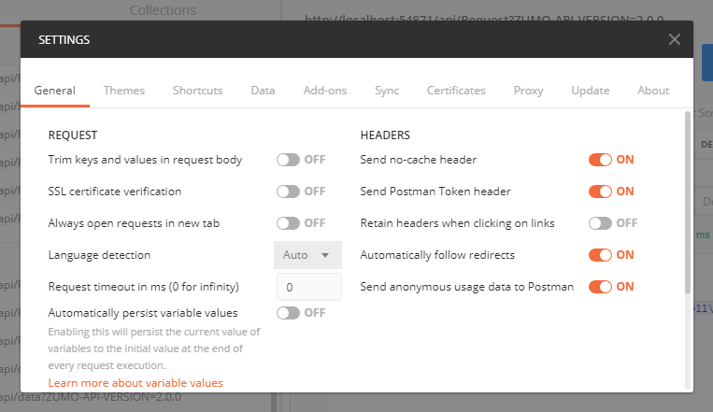

GET

<http://localhost:54871/api/Request?ZUMO-API-VERSION=2.0.0>

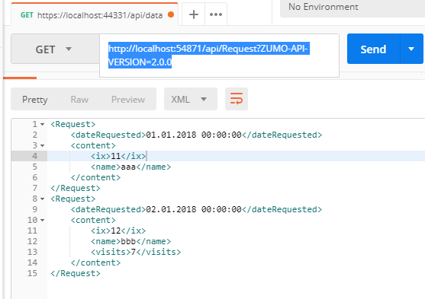

POST LOCALHOST

<http://localhost:54871/api/Request?ZUMO-API-VERSION=2.0.0>

POST AZURE

<https://marcinjoniecxmltest.azurewebsites.net/api/Request?ZUMO-API-VERSION=2.0.0>

HEADERS

KEY

Content-Type

VALUE

application/json

BODY

{

"requests":

[

{

"ix": 11, "name": "aaa", "visits": null, "date": "2018-01-01"

},

{

"ix": 12, "name": "bbb", "visits": 7, "date": "2018-01-02"

}

]

}

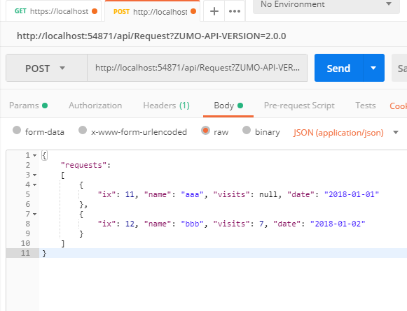

RESULT

LocalDB

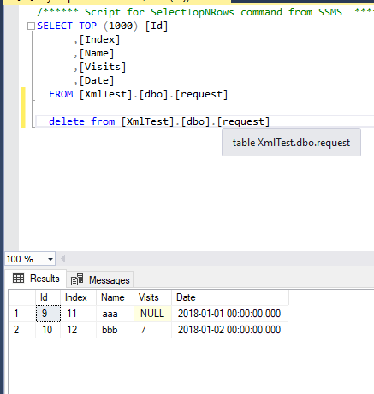

Azure

